2016-Based Household Projections
Background
ONS released 2016-based household projections in September 2018. These update the previous 2014-based projections and the 2012-based projections that were used to inform the Berkshire Strategic Housing Market Assessment (http://www.thamesvalleyberkshire.co.uk/documents?page=1&folder=201&view=files).
Household projections show the number of households there would be in the future if a set of assumptions about the size and structure of the population and that population’s patterns of household formation were realised in practice. The projections generally do not take into account any policy changes that have not yet occurred, nor those that have not yet had an impact on observed trends.
Findings
Between 2018 and 2041, the number of households in Thames Valley Berkshire is projected to increase by 14%, from 362,255 to 413,909 (table 1).
Over the next ten years (2018-2028) the number of households is projected to increase by 7% to 387,132 (table 2). This places the LEP area 18th out of 38 LEPs in terms of expected household growth and is in line with the England average. Greater household growth is expected in neighbouring Buckinghamshire Thames Valley LEP area and in London. Household growth rates are expected to be lower in neighbouring Oxfordshire and Enterprise M3 LEP areas than in Thames Valley Berkshire.
Within Thames Valley Berkshire, household growth over the next 10 years is expected to be greatest (in percentage terms) in Bracknell Forest and Wokingham local authority areas.

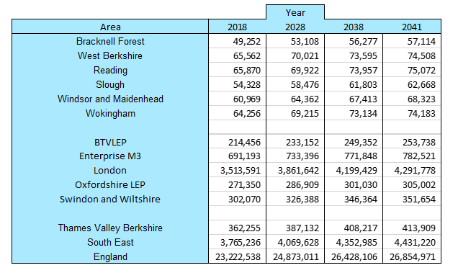
Table 1: The projected number of housing between 2018 and 2041

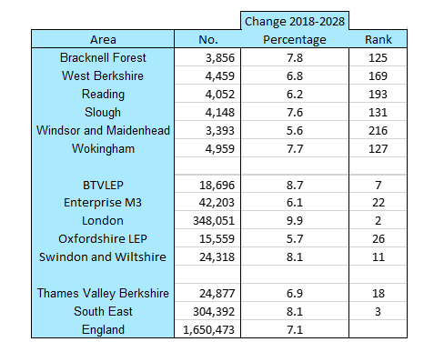
Table 2: The percentage increase between 2018-2028

All data has been sourced by Table 406, ONS, 2018
https://www.ons.gov.uk/peoplepopulationandcommunity/populationandmigration/populationprojections/datasets/householdprojectionsforengland

