**Cost of Housing**

**Average house prices**

In July 2018, the average price for a house in Berkshire was £373,616. This was the 5th highest average price of all 38 LEP areas (table 1).

Within Berkshire, the most expensive place to buy a house is Windsor and Maidenhead, with an average price of £491,495 (23rd highest average price of all England’s local authorities). Average house prices were lowest in Reading, with an average price of £303,065.

Average house prices in Berkshire are around £50,000 higher than the South East average and around £125,000 higher than the England average.

Over the 12 month period from July 2017 to July 2018, house prices in Berkshire rose by 0.9%, lower than the rises in the South East and England’s (1.8% and 3% respectively).Over this period, West Berkshire had the highest annual change in Berkshire (5.1%) and Reading the lowest, with average house prices falling by -2.2% (graph 1).

In comparison the rest of England, Berkshire has one of the lowest annual changes in average house prices, ranking 36th place of the 38 LEPs.

**Rental prices**

Analysing monthly rents recorded between 1st April 2017 to 31st March 2018 we found that within Berkshire, the highest rental prices were in Windsor and Maidenhead (for all types of property) (table 3). West Berkshire and Slough have the lowest mean monthly rents.

Reading has the largest number of rented properties (2,190 properties) and Wokingham the fewest.

**Housing Affordability**

When comparing the housing affordability ratio for each local authority, we see that across all six local authorities in Berkshire there has been a general annual increase in the ratio between house prices and residential earnings, meaning that housing has become less affordable (graph 5).

Over the last five years, Windsor and Maidenhead have had the largest ratio value of all the authorities which means it is the least affordable place to live in Berkshire.

Whereas Reading has consistently over the last 5 years been the most affordable local authority to live as it has had the lowest housing affordability ratios of all the local authorities in Berkshire.

For more information see the house building report with tables on the affordable houses started and completed between 1st April 2018 and 30th September 2018 within TVB.

## **Table 1: Average price, monthly and annual change in house prices - July 2018**

## **Graph 1: Annual change of house prices, July 2018**

**Source:** UK House Price Index: Average price, ONS, July 2018

## **Table 2: Average house prices and annual changes according to type of housing and area**

## **Graph 2: Percentage annual change of house prices by type of housing, July 2018**

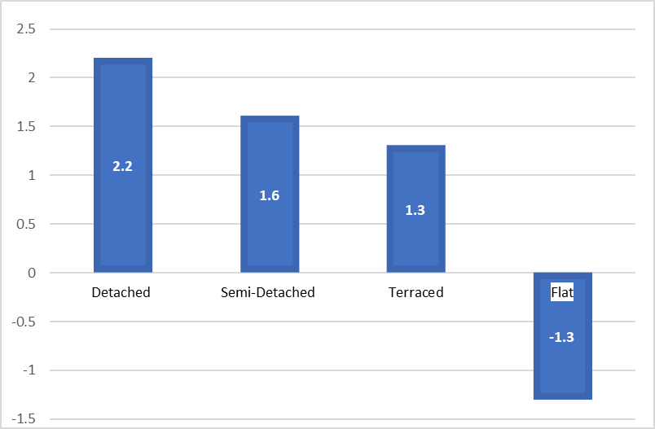

**Source:** UK House Price Index: Average price by property type, ONS, July 2018

**Table 3: Summary of monthly rents recorded between 1st April 2017 to 31st March Source:** Private rental market statistics, VOA, April 2017 to March 2018

**Table 4: Local Authority average weekly rents (£.p), by district, from 1998-99 to 2016-17** LSVT" most of the local authority's stock has been transferred to the Private Registered Provider sector.

"MYT" Local Authorities that have transferred their stock in full, part way through the financial year.

**Source:** Table 702, ONS, 2018

**Table 4: Private Registered Provider (PRP) rents, by district, England 1997 to 2017 (Housing Association etc)**

**Source:** Table 704, ONS, 2018

**Source:** Private rental market statistics, VOA, April 2017 to March 2018

## **Graph 4: Change in median house prices and median earnings**

**Source:** House Price Statistics for Small Areas and the Annual Survey of Hours and Earnings, ONS, 2018

## **Graph 5: Housing affordability ratio**

**Source:** House Price Statistics for Small Areas and the Annual Survey of Hours and Earnings, ONS, 2018