**Housebuilding in Thames Valley Berkshire – Q1 2018**

**Headlines**

3,230 dwellings were completed in Thames Valley Berkshire in the year to Q1 2018, which equates to a dwelling completion rate[1] of 0.9%. This was higher than the national average and the 8th highest rate of all LEP areas.

2,390 dwellings were started in Thames Valley Berkshire the year to Q1 2018. Dwelling start rates[2] were in-line with the national average (roughly 0.7%) and Thames Valley Berkshire was mid-ranked amongst the 38 LEP areas

Within Thames Valley Berkshire, Wokingham was the biggest contributor to dwelling completions and starts in the year to Q1 2018 and had some of the highest housebuilding rates in the country. It had the 7th highest dwelling start rate (1.9%) and the 8th highest rate dwelling completion rate (1.9%) of all 326 local authorities.

Over the same period, Windsor and Maidenhead had the lowest dwelling completion and start rates within Berkshire and was ranked 232nd and 303rd respectively out of 326 local authority areas.

Of Thames Valley Berkshire’s neighbouring LEP areas, Oxfordshire had the highest housebuilding rates (completions and starts).

Over the last five years, Q1 dwelling completions were highest in 2017 and 2018 (table 2 and chart 1), driven largely by a rise in housing completions in Wokingham.

**Recovery since the 2008 financial crash**

The BBC recently examined how well the housing market across the UK has recovered since the 2008 financial crash. Chart 2 shows the extent to which housebuilding in Berkshire was affected, with the number of houses being built falling substantially between the years of 2008/9 and 2012/13.

From 2012/13 the number of houses being built began to pick up slowly, then more quickly between 2014/15 and 2015/16. Across Berkshire as a whole, housebuilding levels have not quite return to the pre-crash high of 2007/8. Mirroring the trend for England as a whole.

Within Berkshire, housebuilding in three local authority areas (Wokingham, Bracknell Forest and Windsor and Maidenhead) in 2016/17 surpassed the pre-crash levels achieved in 2007/8. In 2015/17, Reading’s figures surpassed those of 2007/8, falling a little in 2016/17. Housebuilding in West Berkshire and Slough has not yet surpassed the 2007/8 highs.

**Affordable housing**

Data on building of affordable housing is available for 12 month and six-month periods. Over the latest period (April - September 2018)122 affordable dwellings were completed in Thames Valley Berkshire, the largest number being built in Bracknell Forest (35 dwellings) whilst none were completed in Reading.

Over the same period, the building of 109 affordable dwellings were started. At the forefront was Windsor and Maidenhead with 57% of the affordable dwellings being started in this unitary authority area.

In comparison to the surrounding LEPs, Thames Valley Berkshire started and completed the lowest amount of affordable housing during this period.

## Table 1: Dwelling completed and started in the year to Q1 2018 in and around Berkshire

*Source: DCLG, 2018 (live tables 100 & 253a)*

*[Template designed by Buckinghamshire Business First]*

## Table 2: Dwelling completed in Q1 over the last 5 years in and around Berkshire



*Source: DCLG, 2018 (live tables 100 & 253a)*

## Table 3: Dwelling completed in the year to Q1 2018 by LEP area



*Source: DCLG, 2018 (live tables 100 & 253a)*

## Chart 1: Number of dwellings completed in Q1 in Thames Valley Berkshire over the last five years

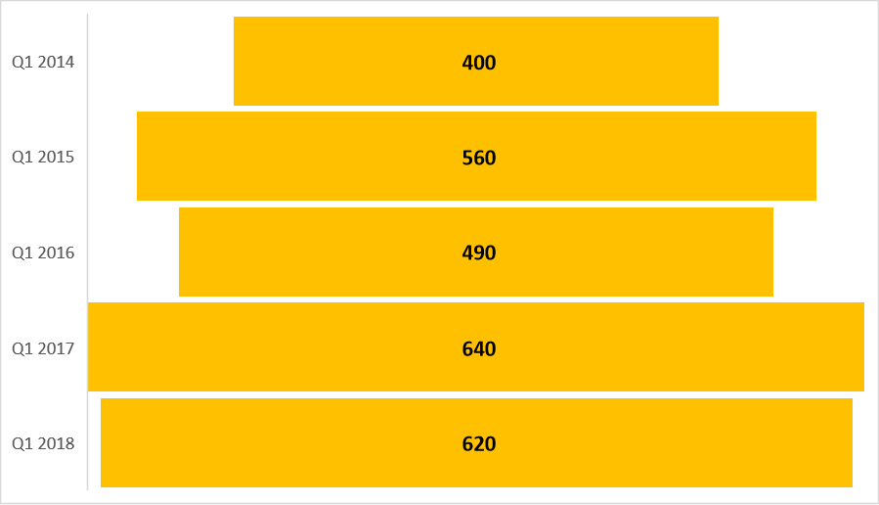

*Source: DCLG, 2018 (live tables 100 & 253a)*

## 

## Chart 2: Number of dwellings built per year in Berkshire’s local authority areas

*Source: BBC 2018*

## Table 4: Affordable dwellings started between 1st April 2018 and 30th September 2018

|  |  |  |  |  |  |  |  |
| --- | --- | --- | --- | --- | --- | --- | --- |
|  |  |  |  | Starts on Site |  |  |  |
| Area | Affordable Rent | Social Rent | Intermediate Rent | Affordable Home Ownership | Total Affordable | Market | Total |
| Bracknell Forest | 3 | 0 | 0 | 8 | 11 | 0 | 11 |
| Reading | 12 | 0 | 0 | 0 | 12 | 0 | 12 |
| Slough | 0 | 0 | 0 | 0 | 0 | 0 | 0 |
| West Berkshire | 0 | 0 | 0 | 0 | 0 | 0 | 0 |
| Windsor and Maidenhead | 23 | 0 | 0 | 39 | 62 | 0 | 62 |
| Wokingham | 2 | 11 | 0 | 11 | 24 | 0 | 24 |
|  |  |  |  |  |  |  |  |
| Thames Valley Berkshire | 40 | 11 | 0 | 58 | 109 | 0 | 109 |
|  |  |  |  |  |  |  |  |
| BTVLEP | 175 | 0 | 0 | 41 | 216 | 0 | 216 |
| Enterprise M3 | 223 | 26 | 0 | 59 | 308 | 194 | 502 |
| Oxfordshire LEP | 87 | 7 | 0 | 26 | 120 | 6 | 126 |
| Swindon and Wiltshire | 249 | 0 | 0 | 59 | 308 | 49 | 357 |
|  |  |  |  |  |  |  |  |
| ENGLAND (Excluding non-Homes England London delivery) | 5,714 | 493 | 190 | 3,512 | 9,909 | 5,857 | 15,766 |

## Table 5: Affordable dwellings completed between 1st April 2018 and 30th September 2018

|  |  |  |  |  |  |  |  |
| --- | --- | --- | --- | --- | --- | --- | --- |
|  |  |  |  | Completions |  |  |  |
| Area | Affordable Rent | Social Rent | Intermediate Rent | Affordable Home Ownership | Total Affordable | Market | Total |
| Bracknell Forest | 0 | 5 | 0 | 28 | 33 | 2 | 35 |
| Reading | 0 | 0 | 0 | 0 | 0 | 0 | 0 |
| Slough | 0 | 0 | 0 | 10 | 10 | 0 | 10 |
| West Berkshire | 16 | 0 | 0 | 4 | 20 | 0 | 20 |
| Windsor and Maidenhead | 30 | 0 | 0 | 0 | 30 | 0 | 30 |
| Wokingham | 0 | 0 | 0 | 27 | 27 | 0 | 27 |
|  |  |  |  |  |  |  |  |
| Thames Valley Berkshire | 46 | 5 | 0 | 69 | 120 | 2 | 122 |
|  |  |  |  |  |  |  |  |
| BTVLEP | 109 | 0 | 0 | 23 | 132 | 0 | 132 |
| Enterprise M3 | 604 | 0 | 0 | 142 | 746 | 151 | 897 |
| Oxfordshire LEP | 302 | 23 | 0 | 30 | 355 | 0 | 355 |
| Swindon and Wiltshire | 141 | 0 | 0 | 29 | 170 | 0 | 170 |
|  |  |  |  |  |  |  |  |
| ENGLAND (Excluding non-Homes England London delivery) | 7,943 | 307 | 9 | 2,832 | 11,091 | 4,613 | ##### |

*Source: Housing Statistics 1 April 2018 to 30 September 2018, ONS, 2018*

Prepared by:

**Niket Sethi**

**Research Assistant**

**Thames Valley Berkshire LEP**

1. *Number of dwellings completed as a proportion of housing stock* 
2. *Number of dwellings started as a proportion of housing stock*